**Capture Cart User Manual (Guide)**

**Introduction**

This document will show how to use all features on Capture Cart website including client and Admin areas of the products.

There is only one main view of the on the page (home page), which will then help you navigate around the website.



This will take you to the home page where you can navigate to products page and also contact the staff for any issues and queries.

This will take you to the admin page where you can update and delete products. You can also create and delete categories

**Client View**

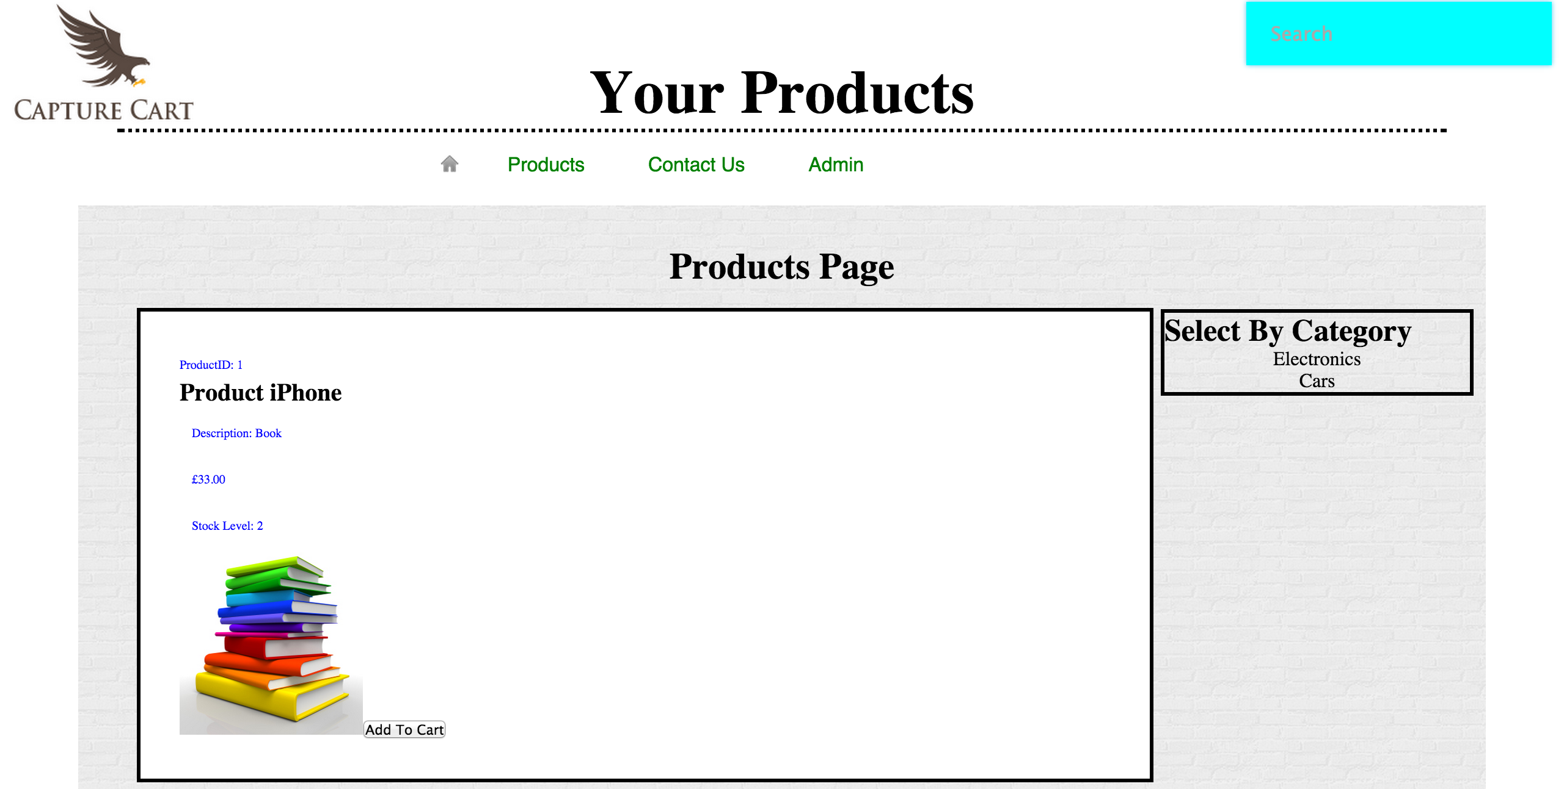**T**his is the client view where they view products or view products by categories and add products to the basket. There is also a live search option on the website, where they can search products.

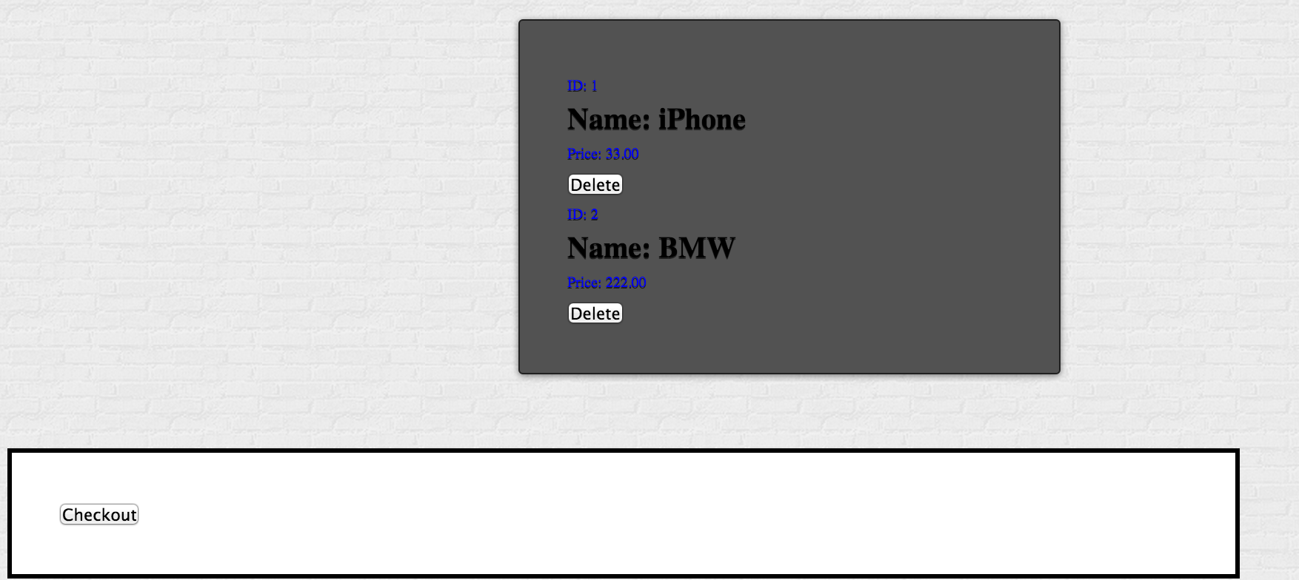At the bottom of the products page on client view, there is a basket where they can add products to the cart and also checkout from there

**Contact us**  page will allow the user to make queries and contact the support team.

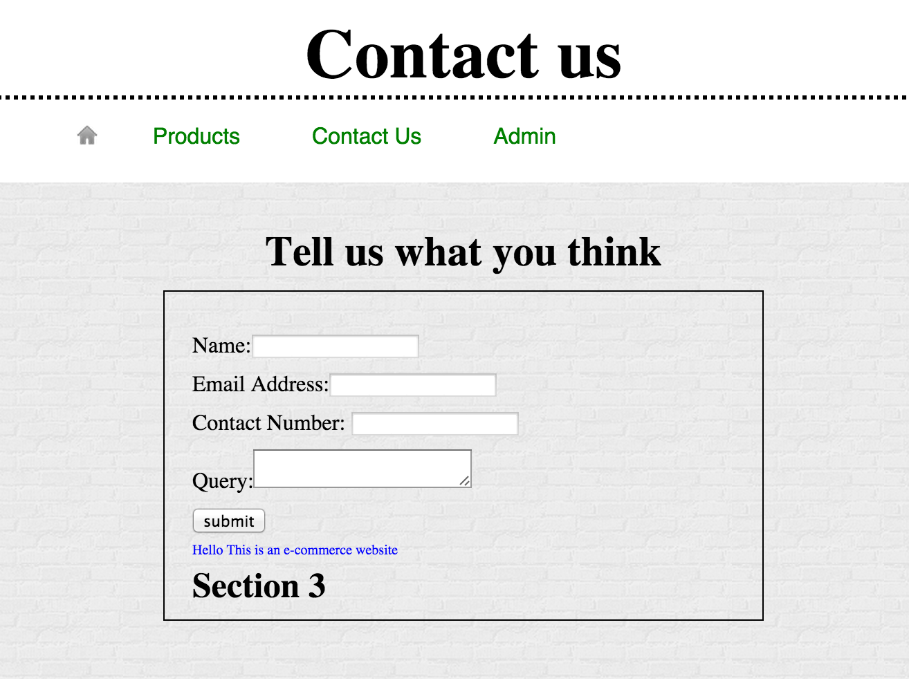

**Admin View**

This will allow them to create a new category. This will show auto-incremented ID and name of the category.

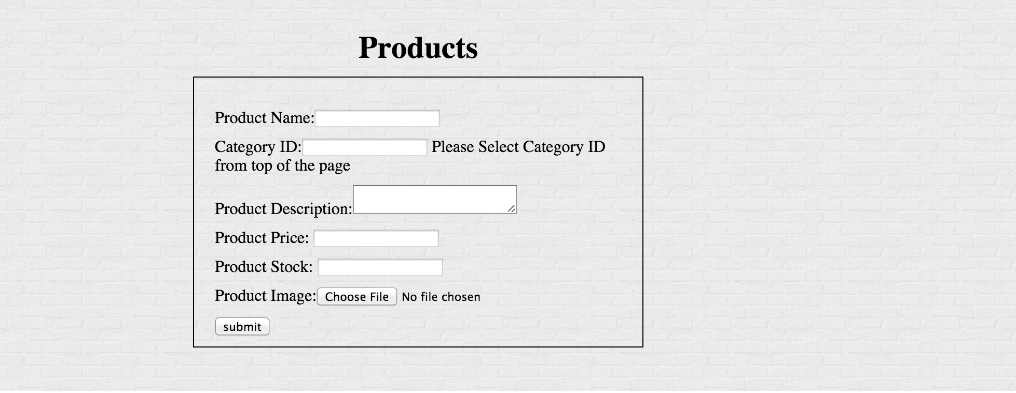

Once admin have created category, they can create new products. However, they will have to manually type the category ID into the system which will be shown on top of this page. You can also add images by only from specific folder.

**Delete, Update/Edit Product**

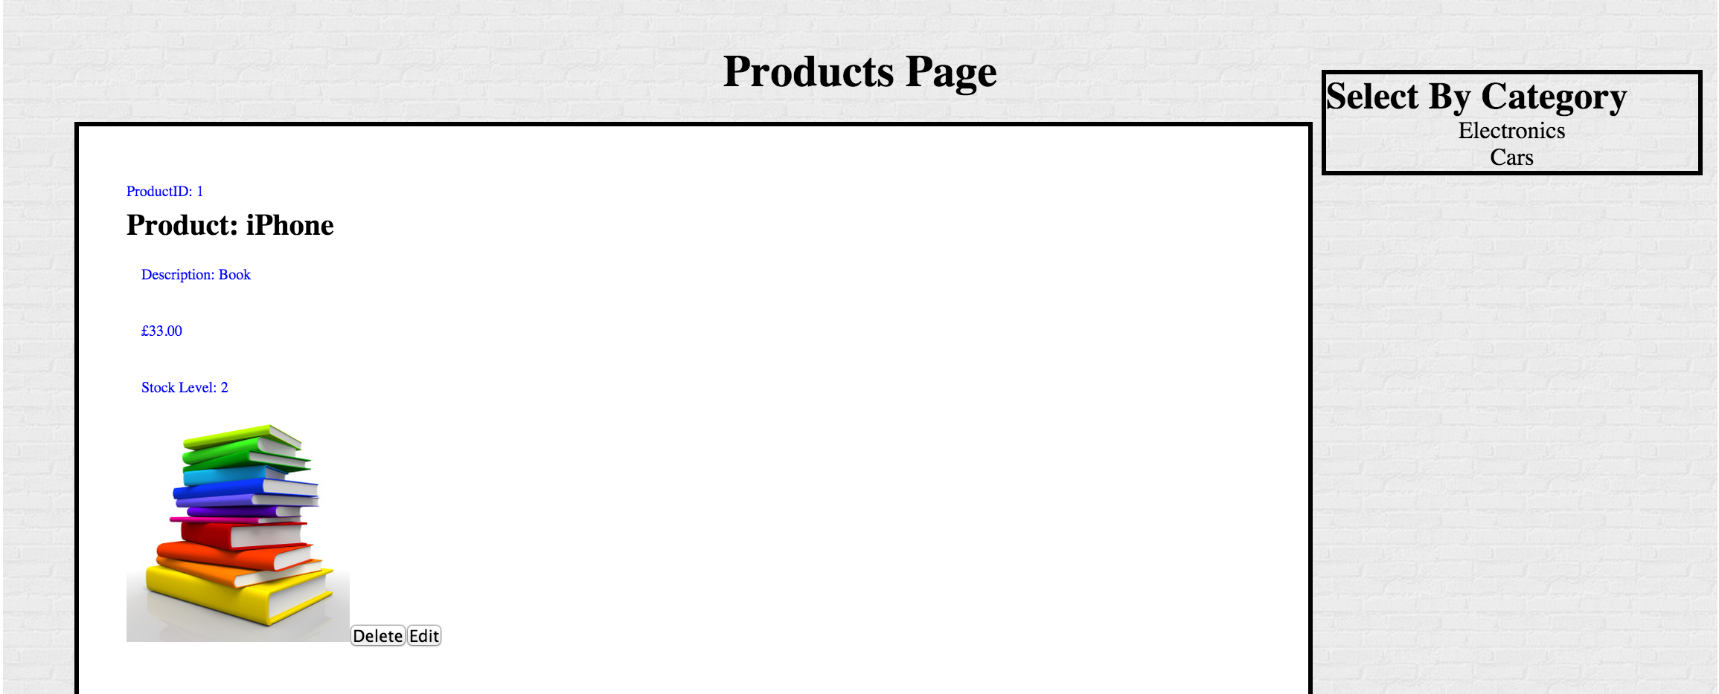

Edit/Update Product

Which will take them to a different page where they can update product name and price.

Delete Product

However, once the user have deleted the product, they must refresh the page so the product can be deleted from the database

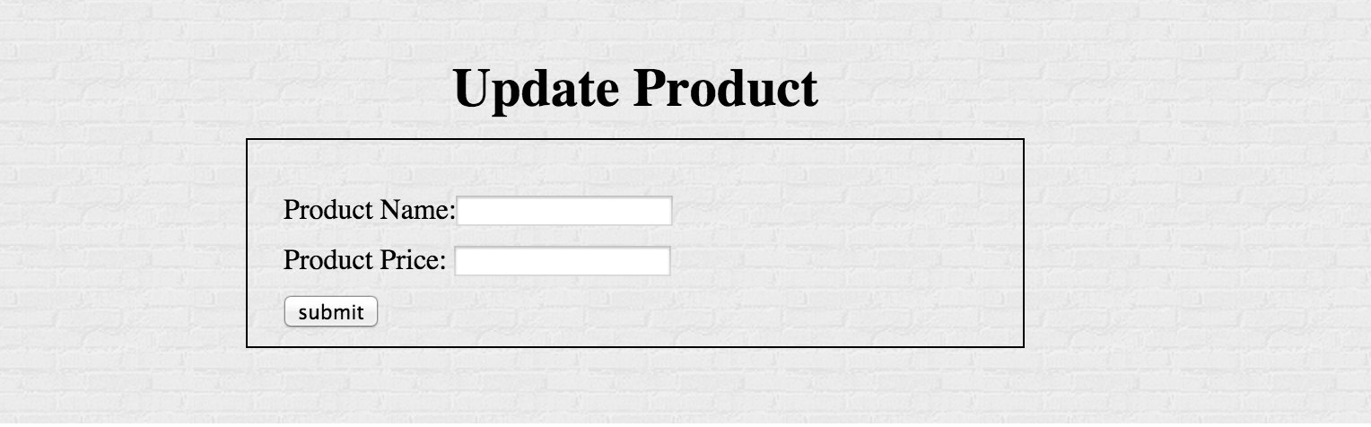

By typing product name and price, the product will be updated.

**Delete Category**

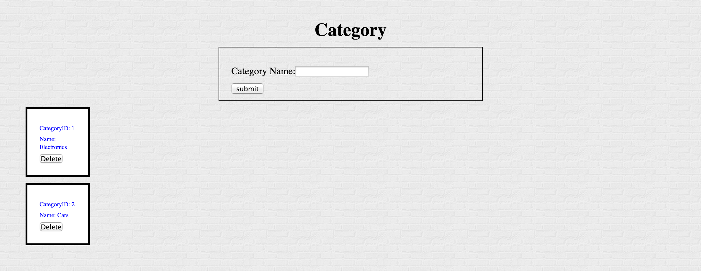

Categories can also be deleted from the admin page.